Multiple-choice section – choose the correct answer

Question 1 [12.1]

Which of the following is not a linear equation?

A  B 1 = C y = x – 4 D 

Question 2 [12.4] [10A]

When simplified, the value of  is:

A 405 B 80.5 C 40.5 D 9

Question 3 [12.3]

5x5 × 8x3 simplifies to:

A 40x15 B 40x8 C 13x15 D 13x8

Question 4 [12.3]

When simplified, (2x5)4 is equivalent to:

A 16x20 B 8x9 C 8x20 D 16x9

Question 5 [12.5] [10A]

The value of (1000) is:

A 100 B 103 C 3 D 10

Question 6 [12.5] [10A]

The value of  is:

A 0.5 B 3 C 2 D 2

Question 7 [12.1]

The horizontal asymptote of the exponential  is:

A x = 3 B y = 3 C y = 4 D y = 0

Question 8 [12.2]

The graph of  is:  
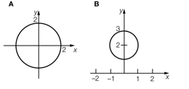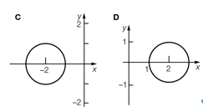

Multiple-choice results: ___ / 8

Short answer section

Question 10 2 marks [12.5] [10A]

Choose from the following words to complete the sentences below.

base coefficient index irrational number power surd

In the term 5x6, the ‘x’ is known as the ________ and 5 is known as the _____________.

Question 11 1 mark [12.5] [10A]

Complete the following sentence.

(81) = 4 because ______________________________________________________

Question 12 2 marks [12.4] [10A]

Simplify × .

Question 13 2 marks [12.3]

Express 2*a*3*b*2 with positive indices.

Question 14 2 marks [12.3]

Write (*a*3*b*2)2 in simplified form expressing your answer with positive indices.

Question 15 6 marks [12.5] [10A]

Simplify:

(a) (12) + (3) (b) (50) – (10) (c) 3(2)

Question 16 6 marks [12.2]

**(a)** Write the equation formed if the circle with equation *x*2 + *y*2 = 9 is translated 3 units left  
and 2 units up.

**(b)** What is the centre of the transformed equation?

**(c)** What is the radius of the transformed equation?

**(d)** Sketch the graph of the transformed equation.

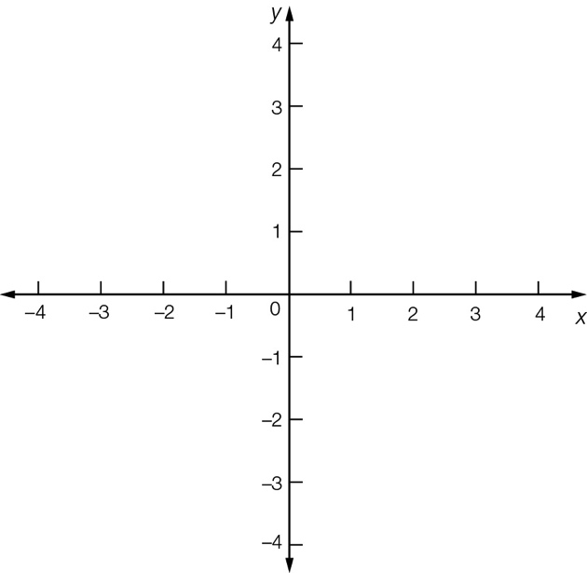

Question 17 4 marks [12.2]

**(a)** Write the equation formed when the exponential graph with equation *y* = 3*x* is translated 1 unit to the left and 2 units down.

**(b)** Sketch the graph of the transformed equation.

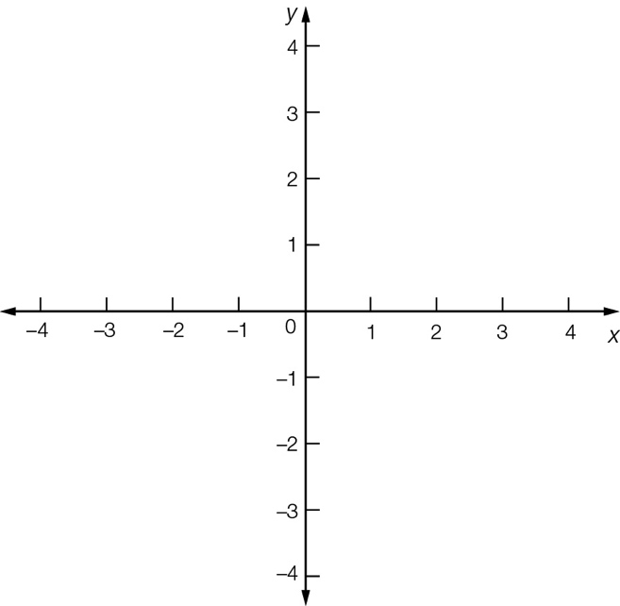

Question 18 6 marks [12.2]

(a) Write the equation formed if the graph with equation y =  is translated 2 units right and 1 unit down.

**(b)** What is the value of the horizontal asymptote?

**(c)** What is the value of the vertical asymptote?

**(d)** Sketch the graph of the transformed equation clearly showing the *x-* and *y*-intercepts.

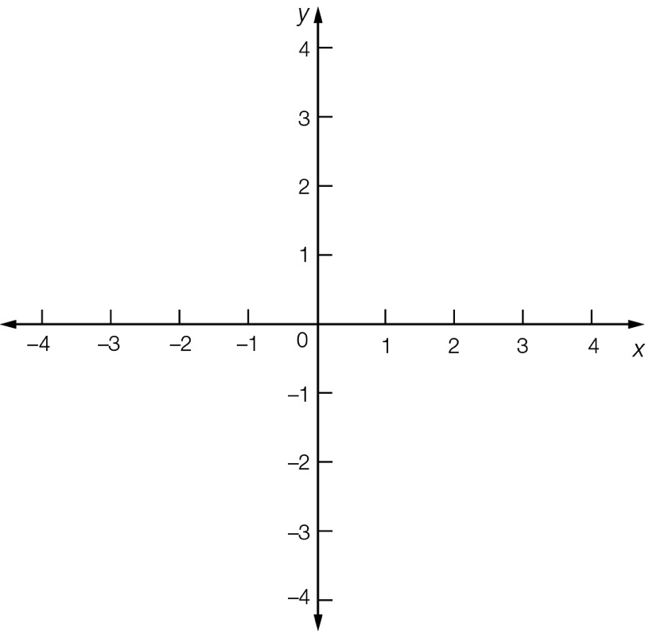

Short answer total:______ / 31

Extended answer section

Question 19 8 marks [12.1, 12.2]

(a) Write the equation of a circle with a centre at (-1, 2) and radius 4 units.

**(b)** Plot the graph of this circle showing all relevant points.

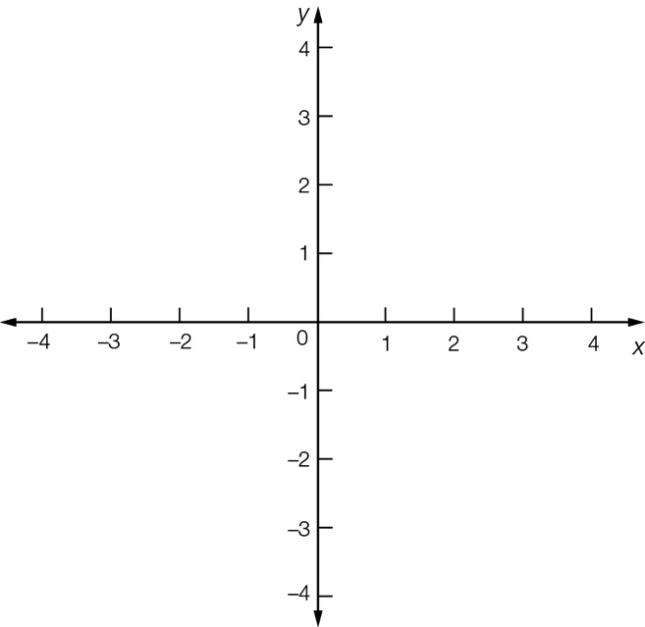

**(c)** What is the new equation formed if this circle has its radius increased by 2 units.

**(d)** Sketch the graph of this circle.



**(e)** The graph in (d) is reflected in the x-axis. State the centre and the radius of this circle.

Question 20 8 marks [12.2]

When heated slowly, the temperature *T* °C of a vintage clothes iron increases according to the exponential rule , where *t* is the time in minutes.

(a) What is the initial temperature of the vintage clothes iron?

(b) What is the temperature of the vintage clothes iron after 2 minutes?

**(c)** Use the information from (a) and (b) to help you sketch the graph of .

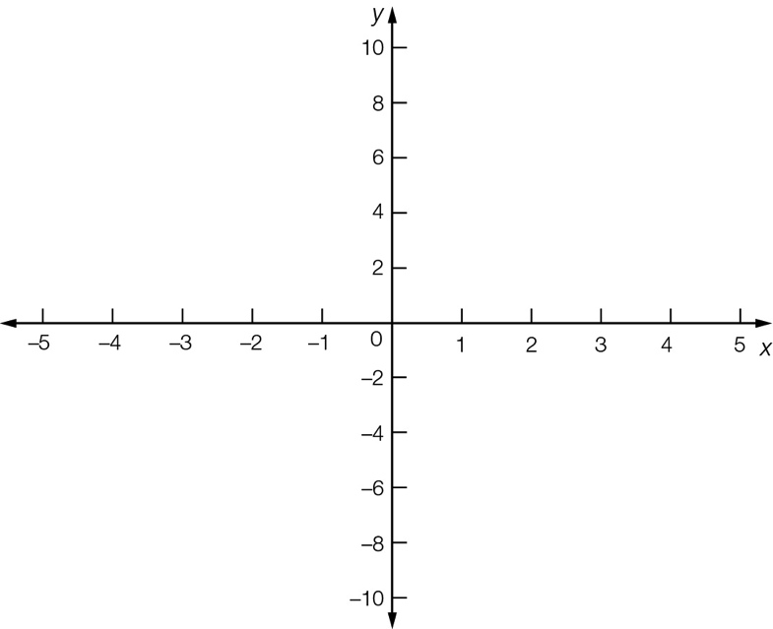

**(d)** Show that after 5 minutes the temperature of the vintage clothes iron will be 31 °C more than its initial temperature.

Extended answer total:______/16

TOTAL test results: _____ / 55